GRADE 7 ACCELERATED · UNIT 2 · LESSON 5
Rational and Irrational Numbers on the Number Line
Additional Practice 7A.02.05 ANSWER KEY

1. Sort the seven numbers into the table. Two of them carry a radical sign and are still rational.
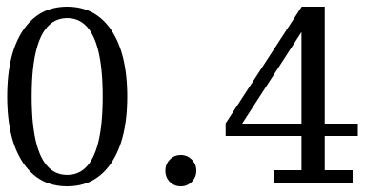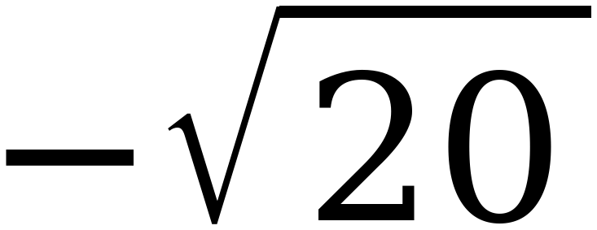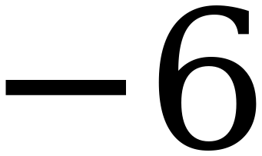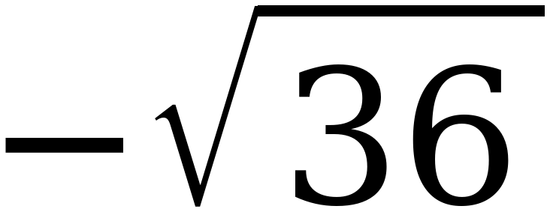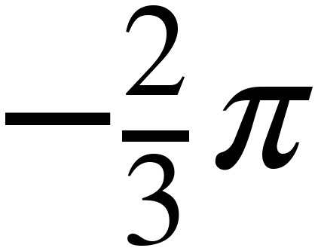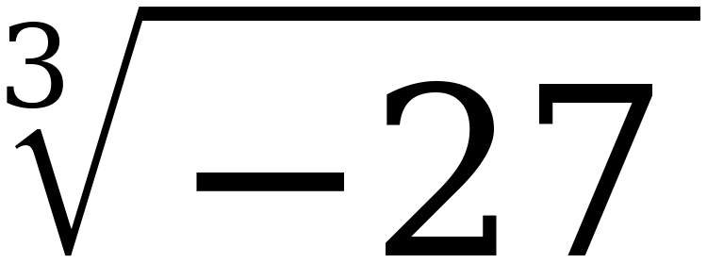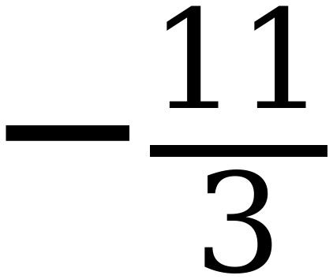
Rational | Irrational
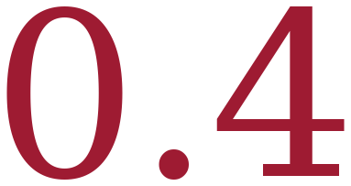 | 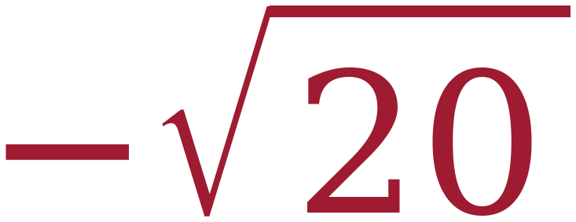
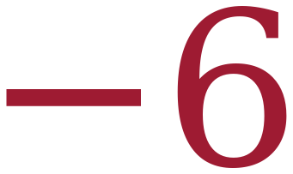 | 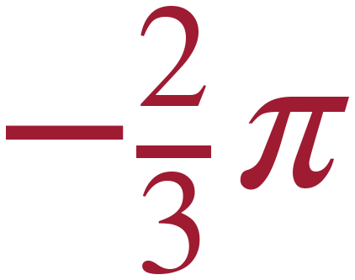
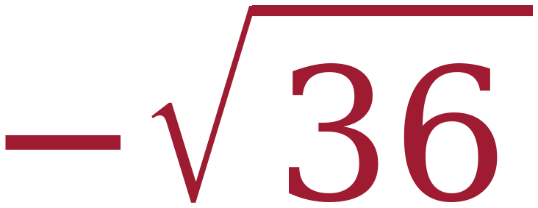
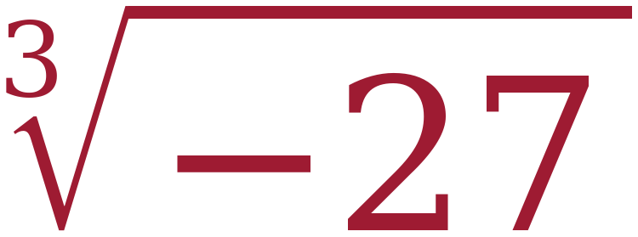
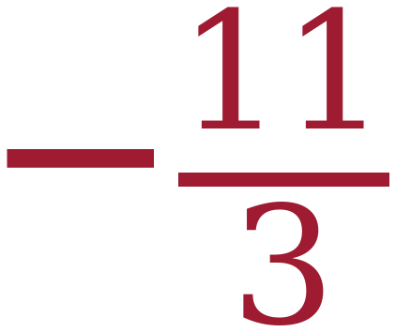

−√36 = −6 and ∛−27 = −3 are the two traps. −11/3 is printed as a ratio already and needs no work. 20 is not a perfect square, so −√20 is irrational; and −⅔π is π scaled by a NON-ZERO rational number, which stays irrational — the qualifier matters, because 0 × π = 0 is rational, and the Reference Sheet states the rule that way.
For questions 2 through 7, compare each pair using <, > or =.
2. | 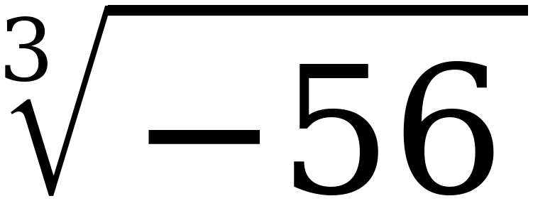 | < | 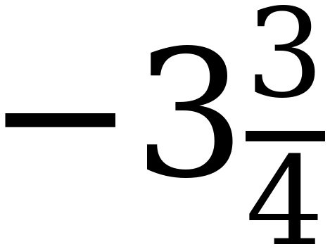
3. | 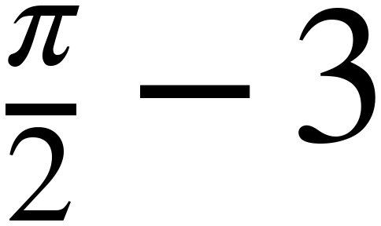 | = | −3 + ½π
4. | 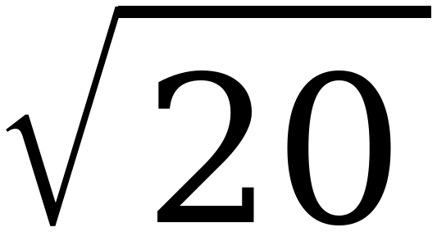 | > | 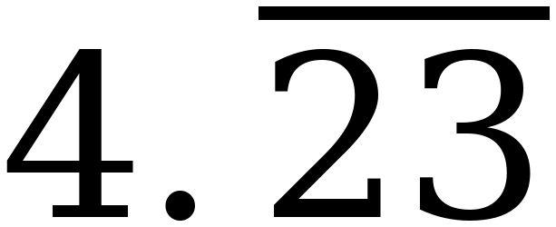
5. | 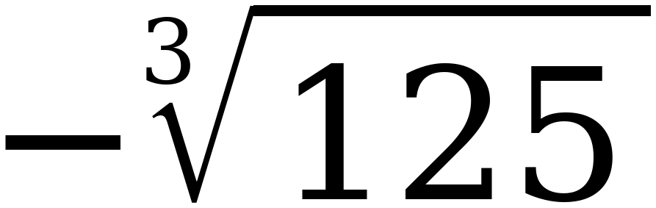 | > | 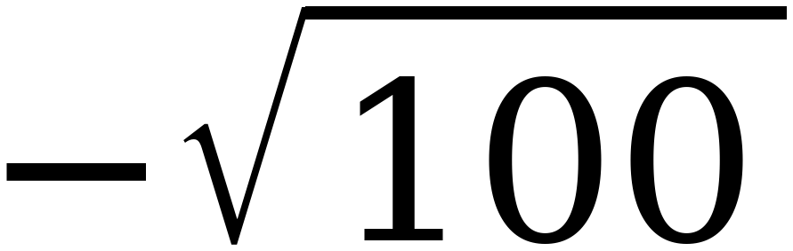
6. | 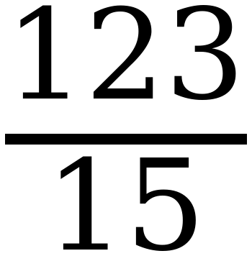 | < | 8.25
7. | 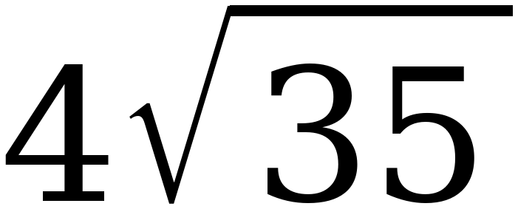 | > | 23.12122…

Question 3 is the equality: π/2 − 3 and −3 + π/2 are the same expression written two ways, and a student who reaches for a calculator will still get =. Question 5 is the negatives trap — −5 is greater than −10.
8. Order the numbers from least to greatest, then plot and label each one.
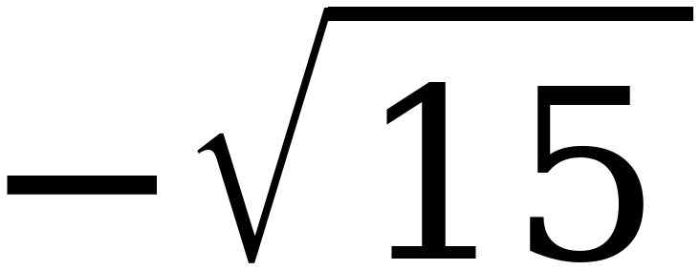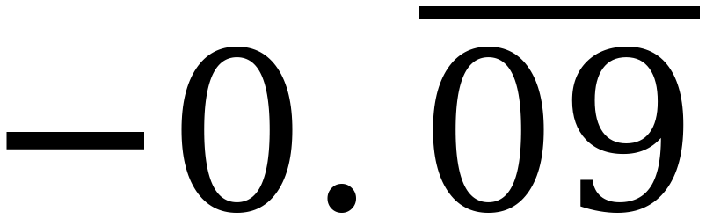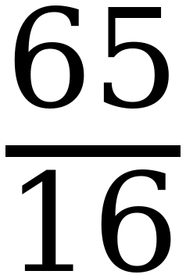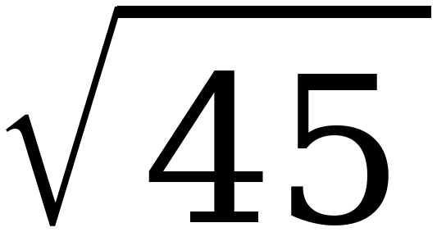
−√15 , −⅔π , 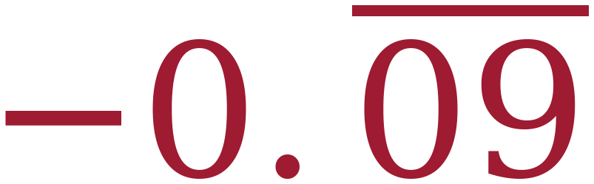 , 65/16 , √45
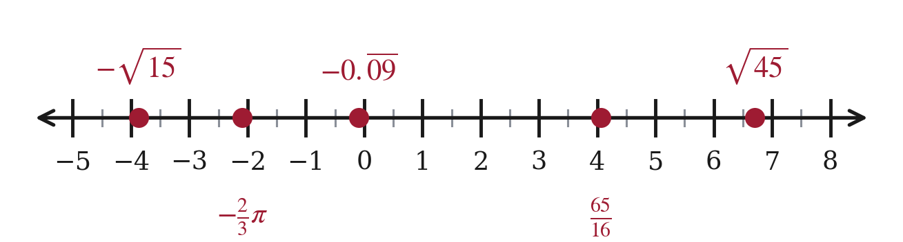
Decimal values: −3.873; −2.094; −0.0909…; 4.0625; 6.708. The repeating decimal −0.09090909… equals −1/11. It is the closest of the five to zero, and a student who reads it as −0.9 will put it in the wrong place.
9. Order the numbers from least to greatest, then plot and label each one.
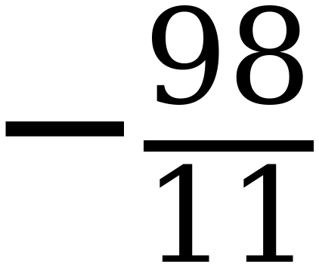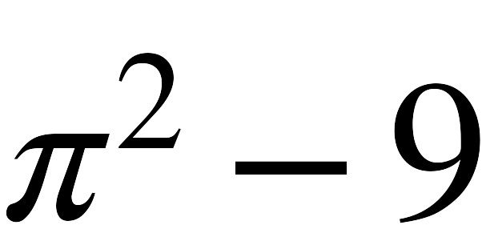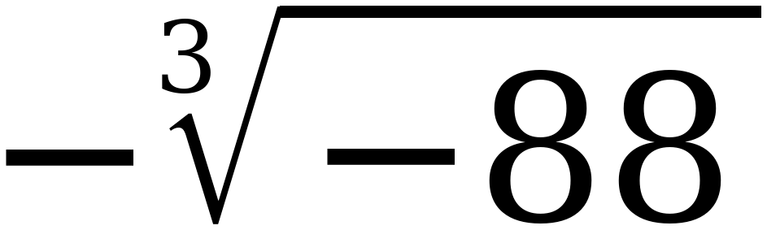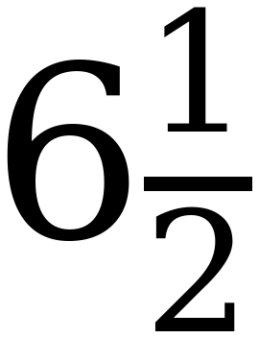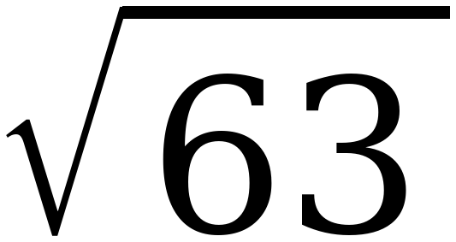
−98/11 , π² − 9 , −∛−88 , 6½ , √63
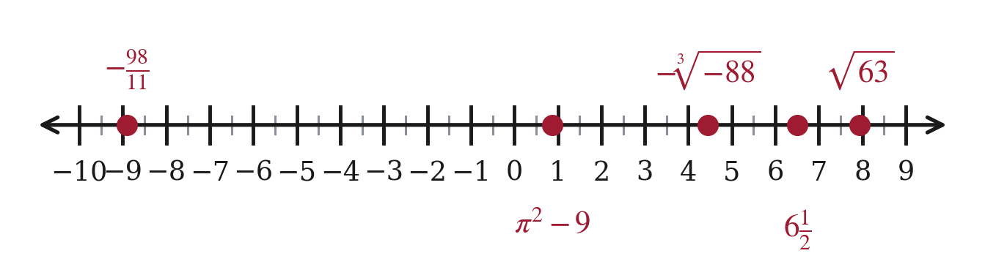
Decimal values: −8.909; 0.870; 4.448; 6.5; 7.937. The third one is a double negative — ∛−88 ≈ −4.448, so its opposite is positive.
10. Which is greater, or ? Explain how you decided, and say what a student who answers the other way is doing wrong.
−⅔π is greater. −√36 = −6 and −⅔π ≈ −2.09, and −2.09 sits to the right of −6.
A student who answers −√36 is comparing 6 against 2.09 and ignoring the sign.
With negatives, the number that looks bigger is the smaller one. Further left on the number line always means less.

